Introduction
This assignment introduced essential tools and principles for Python development, version control, and algorithm implementation. Main objectives included establishing a Python environment, configuring Visual Studio Code as the IDE, creating a GitHub account for version management, and coding the Insertion Sort algorithm adapted for monotonically decreasing order. The following sections describe the setup process and programming tasks with relevant screenshots.

Step 1: Installing Python
The first task involved verifying Python's proper installation. As Python is fundamental to this assignment, downloading and installing the latest version was essential. During installation, I selected "Add Python to PATH" to ensure terminal and command prompt accessibility. I confirmed successful setup by opening the terminal and running python --version, which displayed the version number, verifying Python was ready for development.
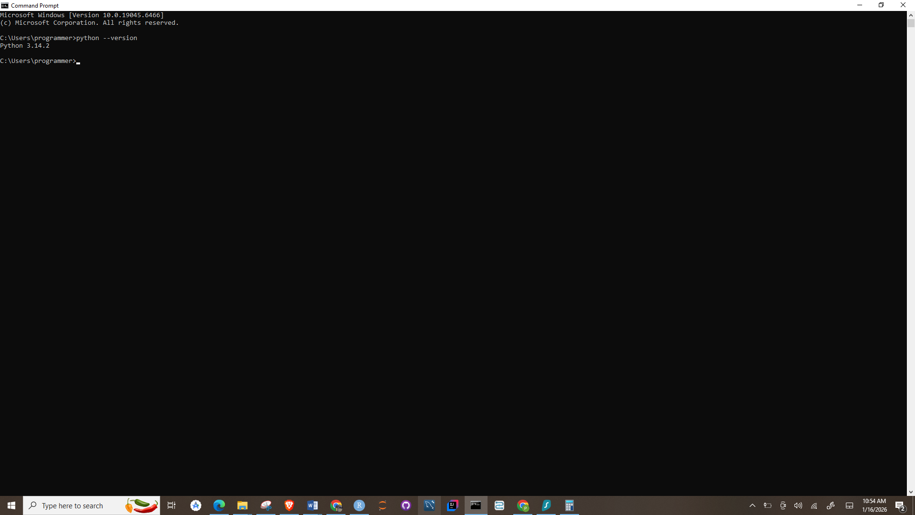
Figure 1 Python installation and terminal check

Step 2: Installing Visual Studio Code (VS Code)
After installing Python, the next step was setting up Visual Studio Code (VS Code) as the development environment. VS Code is a lightweight yet powerful code editor supporting Python development through extensions (Ariamajd et al., 2025). Following installation, I launched VS Code and installed the Python extension to enable Python functionality (Chen et al., 2025). Additionally, I added the Code Runner extension, allowing direct code execution within VS Code. This setup ensured an optimized environment for writing, running, and debugging Python programs.
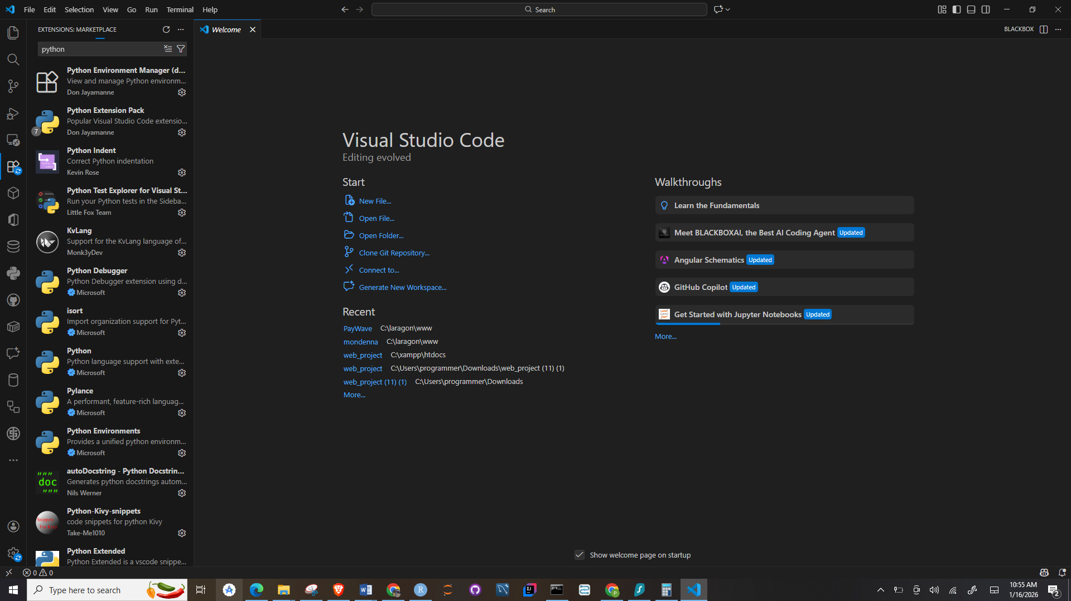
Figure 2 Installing Python extension in VS Code

Step 3: Creating a GitHub Account
To meet the assignment’s version control requirements, a GitHub account was created to manage and track code changes. GitHub, integrated with Visual Studio Code, enabled efficient version management directly within the development environment (Ariamajd et al., 2025). Following a tutorial, the account was successfully connected, allowing commits and uploads. A public repository named MSCS532_Assignment1 was then created to store the project files.
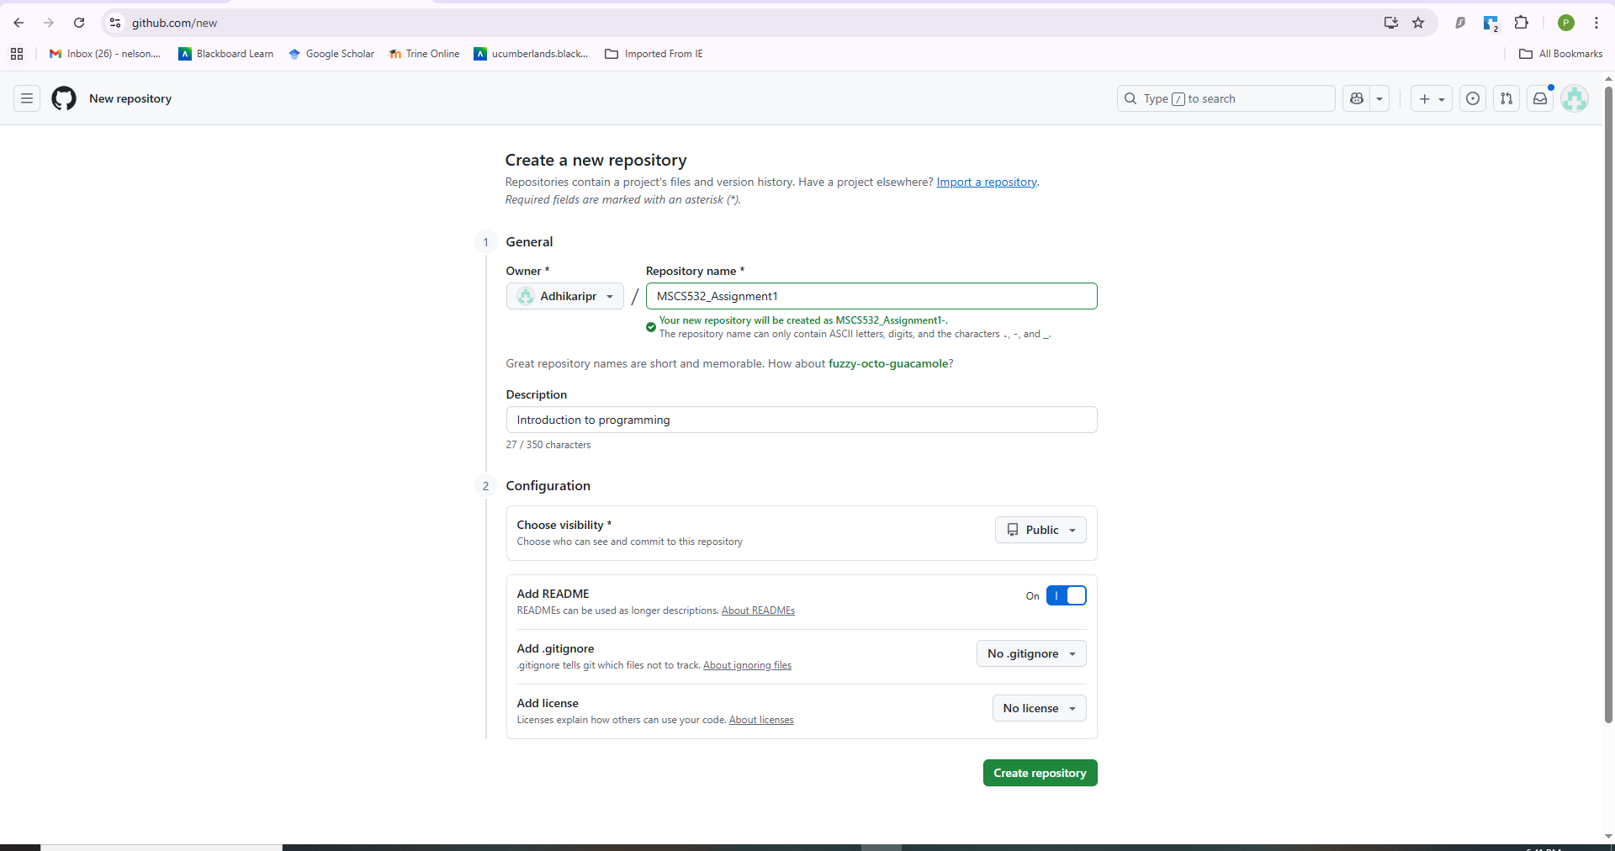
Figure 3 GitHub repository creation

Step 4: Implementing Insertion Sort in Monotonically Decreasing Order
After configuring the required tools, I focused on implementing the Insertion Sort algorithm. As described in Introduction to Algorithms (Wessel et al., 2022), Insertion Sort typically arranges elements in ascending order. For this assignment, the comparison logic was modified to sort the array in monotonically decreasing order (Chen et al., 2025). The algorithm iteratively repositioned elements to the left when larger values were encountered. The implementation was tested using multiple datasets to ensure correctness and reliability.
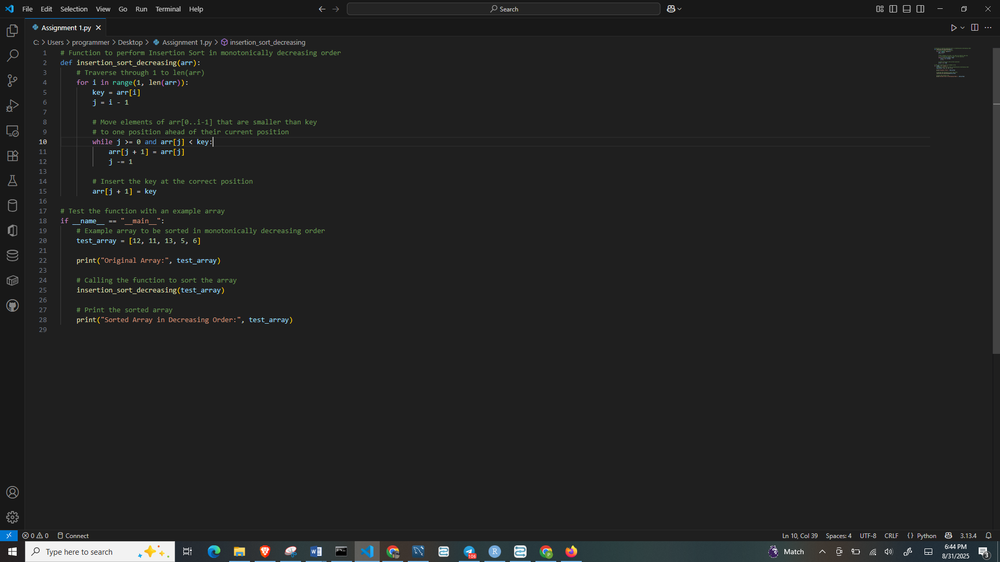
Figure 4 Python code for Insertion Sort algorithm

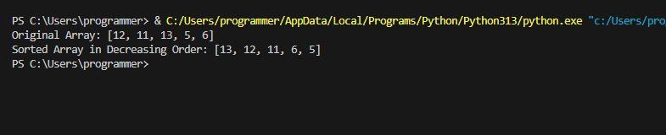
Figure 5 Test run showing sorted array

Step 5: Version Control and GitHub Commits
Throughout the development process, GitHub was used for version control to track progress and manage changes. At least three commits were completed to document key development stages (Vergopoulos et al., 2025). The first commit captured the initial project setup and basic Insertion Sort implementation. The second commit reflected modifications to sort the array in descending order, while the final commit followed testing and validation. Each commit included clear descriptive messages, ensuring transparency, traceability, and reliable version recovery.
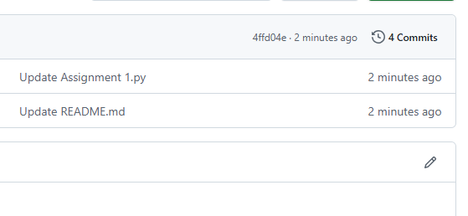
Figure 6 Commit history in GitHub repository

Conclusion
This assignment effectively introduced the technologies and principles essential for Python development, version management, and algorithmic execution. Through installing Python and Visual Studio Code, establishing GitHub for version control, and coding a modified implementation of the Insertion Sort algorithm, I acquired practical experience in creating a development environment and overseeing a programming project. The exercise of arranging an array in monotonically decreasing sequence enhanced my comprehension of the Insertion Sort algorithm's operations and the significance of precision when coding algorithms.

References
Ariamajd, A., de Castro, R. L. R., & Volkamer, A. (2025). PyPackIT: Automated Research Software Engineering for Scientific Python Applications on GitHub. arXiv preprint arXiv:2503.04921.
Chen, K. Y., Toro-Moreno, M., & Subramaniam, A. R. (2025). GitHub is an effective platform for collaborative and reproducible laboratory research. ArXiv, arXiv-2408.
Vergopoulos, K., Müller, M. N., & Vechev, M. (2025). Automated benchmark generation for repository-level coding tasks. arXiv preprint arXiv:2503.07701.

